

Principles Of Bigdata

Phase-I

**Submitted By-**

Bhuvana Atluri(16186197)

Spandana Surapaneni(16186540)

Surya Prabha Ghanta(12449107)

Tweets Downloading:

In order to perform word count first we need to download tweets from twitter. We have written a java program to perform this task. In the java program we have used “twitter4j” API. You can find our Java program in the “StreamTweets.java”.

Map Reduce:

In Spark we used Scala to perform Map reduce function on the tweets file. After using this function we have stored the output to the file using “saveAsTextFile” command. We have added all the required Screen Shots below:

Map Reduce:

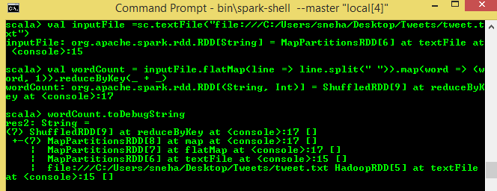

Write results to HDFS:

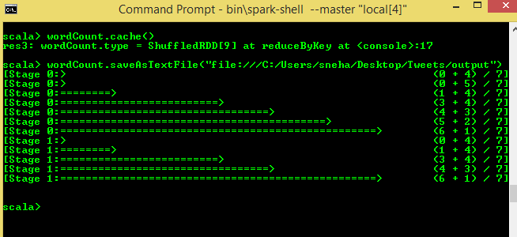

**GitHub Link for Phase 1 of the project:**